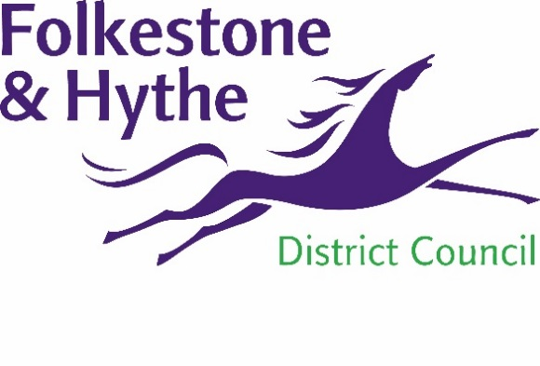
NEWS RELEASE

10 August 2021

Opportunity to comment on the draft Folkestone Town Centre Place Plan

Final feedback on the actions and priorities included in Folkestone town centre’s draft Place Plan is being sought from residents and businesses.
The Place Plan sets the direction for a sustainable and vibrant future for Folkestone Town Centre. Folkestone & Hythe District Council commissioned this work to ensure we can create the best future for Folkestone town centre and for all those who live in, work in and visit it.
Urbanism consultants We Made That have led on the Place Plan project, supported by a wide range of experts from other organisations giving input on.
Work to develop the Place Plan has been ongoing since February and over this period multiple workshops, surveys and webinars have been held to encourage as much engagement as possible.
The Place Plan identifies six key missions to overcome “the grand challenge”. This challenge has been identified by We Made That as stemming decline within the town centre, attracting investment, bringing together community groups whilst addressing the climate emergency. The draft plan presents tangible and exciting proposals for possible future changes to the area such as improved access into and throughout the town centre, business and employment opportunities, potential for more homes, and more green spaces.
The actions - which have suggested prioritisations – are the ways in which the ambition set out in the plan will be achieved. The plan recognises that there is a role for the council, public sector partners, businesses, investors and the community to deliver these actions.
Leader of Folkestone & Hythe District Council, Cllr David Monk, said: “This project has progressed well and we want to give people the chance to submit any final comments on the priorities and actions that have emerged
Cabinet Member for the District Economy, Cllr David Wimble said: “I’m grateful to all those who have engaged with us through this project. All feedback and insights have been considered and this has helped shape the creation of final draft of this Place Plan.”
This final draft of the document will be going to Cabinet on 22 September 2021.
Residents and businesses have a chance to comment on the actions and priorities in the final draft of the Place Plan document until 20 August 2021.
To view the final draft of the Place Plan and find out how to comment please visit folkestone-hythe.gov.uk/folkestoneplaceplan

ENDS
Notes to Editors
For more information, please email communications@folkestone-hythe.gov.uk

Follow us on Facebook: @FolkestoneandHytheDC
Follow us on Twitter: @fstonehythedc
Follow us on Instagram: @folkestonehythedc
Follow us on LinkedIn: Folkestone & Hythe District Council

